Usability Test – Typography
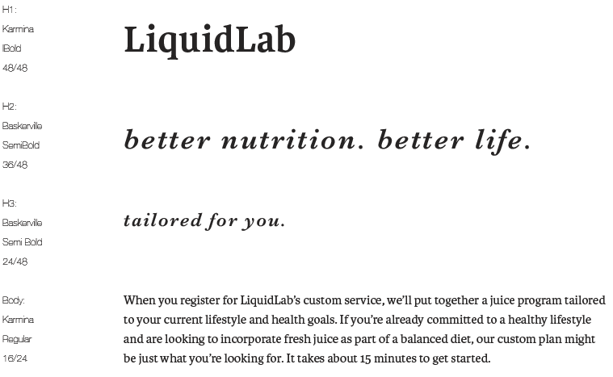
Typography Option 1
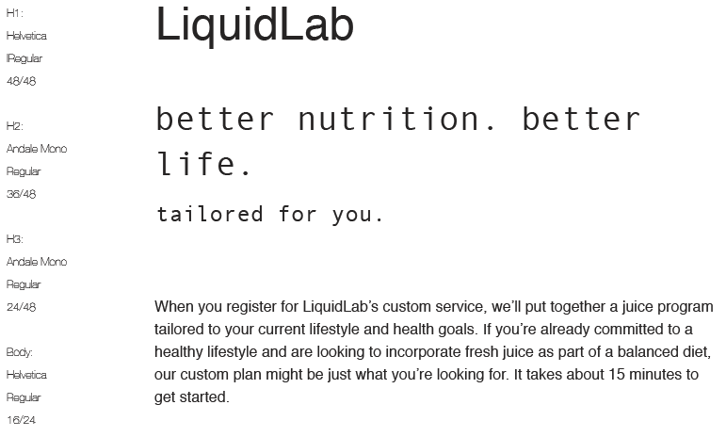
Typography Option 2
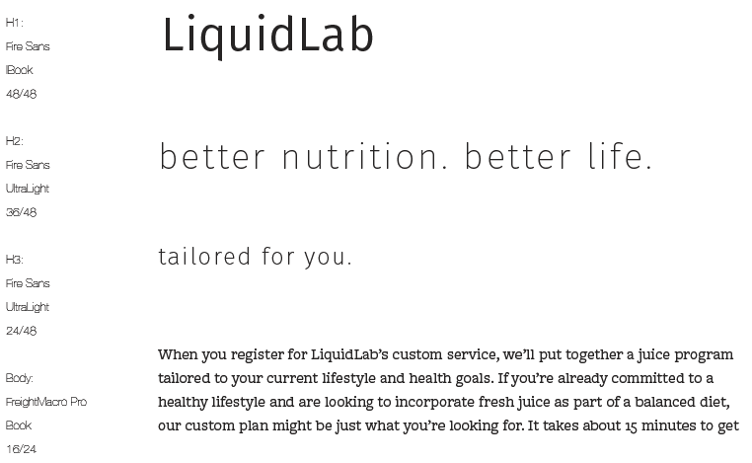
Typography Option 3
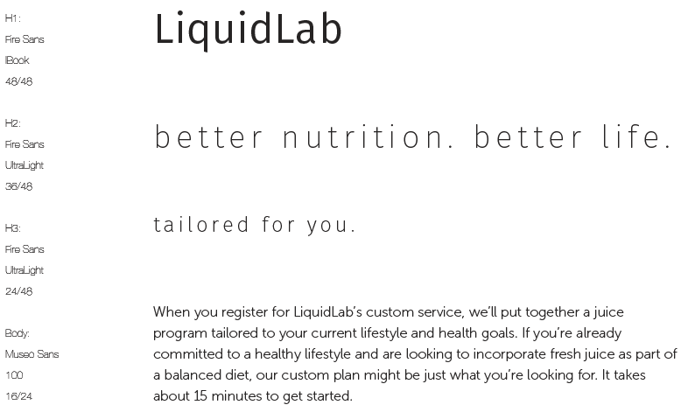
Typography Option 4

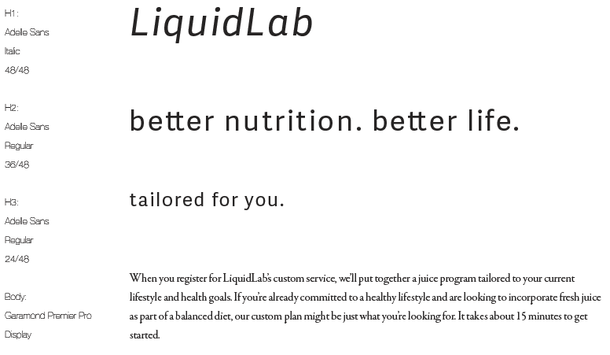
Typography Option 5
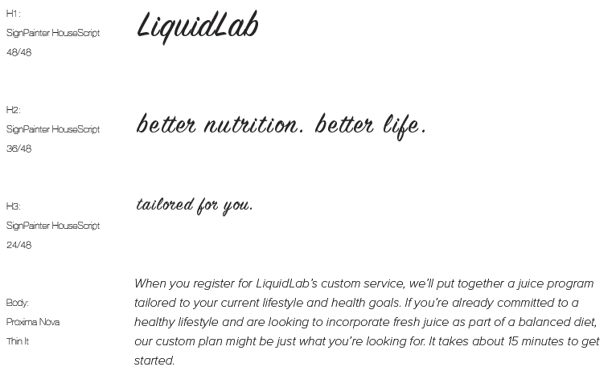
Typography Option 6

Results of Interviews
- Presented the 6x options to 3x target audience members with no discussions allowed. Responses needed to be written down and not shared.
- Requested users to be honest and not worry about there being a right or wrong answer as this was a subjective exercise.
- Initial question that was asked was to select the 2x most favourite options that appealed to them
- Product brief was provided, then the same question was asked which was to select the 2x most favourite options that appealed to them.
- I then broke down each element and asked which H1 helped communicate the brand best – followed with H2, H3 and Body
- The results of the interview found significant appeal was predominantly with Option 4 with Option 2 as a possibility. This confirmed my initial design preference with Option 4 which I have adopted throughout my design.

- Which colour scheme appeals to you the most now that you have heard about the product? (select 2 and rank in order of preference)
 | Option 1 | Option 2 | Option 3 | Option 4 | Option 5 | Option 6
Alan | 2 | 1 | 2
Clarissa |  | 1 |  |  |  | 2
Victoria |  |  |  | 2 |  | 1

- How do the colours in the schemes that you have selected make you feel? (in one or two words for each option that you previously selected)
Option 1 - nature;
Option 2 - organic, clean, calm;
option 3 - fresh;
Option 6 - bright
- Now thinking about the product along with the following keywords: “healthy”, “nutritional” and “high-quality” – does this affect your colour scheme preferences? (select 2 and rank in order of preference)
 | Option 1 | Option 2 | Option 3 | Option 4 | Option 5 | Option 6
Alan | 1 |  | 2
Clarissa | 1
Victoria |  |  |  | 2 | 2 | 1

- Now that I have explained how the choice of colours will be used on the landing page (main, text, background, accents) – what colour schemes best resonate the brand? (select 2 and rank in order of preference)
 | Option 1 | Option 2 | Option 3 | Option 4 | Option 5 | Option 6
Alan | 2 |  | 1
Clarissa | 2 | 1
Victoria |  |  |  | 1 | 2

